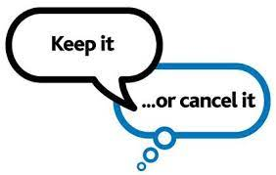

**Use our online triage system**

**Use the NHS or Patient Access App**

 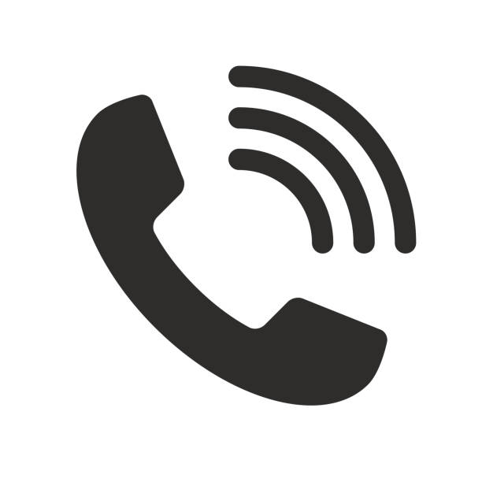

Use our online triage system

**If you are unable to attend, please always cancel your appointment. There are various ways to do this:**

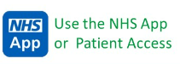

**Contact us by phone and use our automated system or speak with a member of our Navigation Team**

**0117 966 3149**

**In the month of November, we had 287 appointments go to waste because patients did not attend them. These appointments were made up as follows:**

* **120** GP / ANP Appointments
* **98** Nurse Appointments
* **42** HCA/Phlebotomy/GPA Appointments
* **18** Physio/HWBC/Social Prescriber/Mental Health Worker Appointments